Executive Committee Meeting
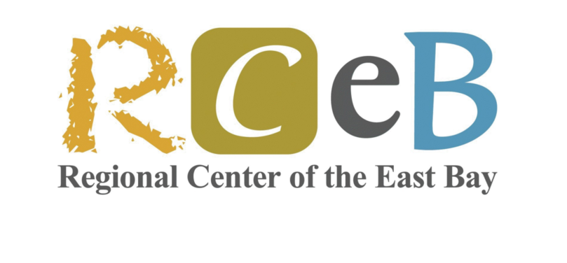

Regional Center of East Bay
Wednesday, October 14th, 2026 at 6:00pm PDT to 7:00pm PDT

Meeting Details:
https://us06web.zoom.us/j/85844144165?pwd=N995s0QYkQc6WHfibavgy5rezHgWYj.1

Meeting ID: 858 4414 4165
Passcode: 446644
Agenda
- Check in 6:00 PM
Presenters: Sadia Mumtaz, Rajesh Voddiraju
  - Mission and Vision
Presenter: Sadia Mumtaz
THE MISSION THAT GUIDES US: Driven by the belief that everyone deserves to lead a life of their choosing, RCEB partners with individuals with intellectual and developmental disabilities, their families, and the community, to create opportunities for independence and fulfillment.
THE VISION THAT INSPIRES US: We envision a future where individuals with intellectual and developmental disabilities live and work, doing what they love, without limitations!
Cultivating Connection - Empathetic Stewardship - Seizing Opportunities - Intentional Adaptability
- Updates 6:03 PM
Presenters: Sadia Mumtaz, Rajesh Voddiraju
  - Board recruitment
  - RCEB Bylaws

- Current Issues 6:20 PM
Presenters: Sadia Mumtaz, Rajesh Voddiraju, David Glasser, Rebecca Nanyonjo
  - RCEB Visit by Board. Special focus on introducing new Board Members to RCEB
  - Board Training – Materials from ARCA vs RCEB Custom Training
  - Executive Director Evaluation
  - Board Support Budget (Legal and Other)
  - Hybrid Board meeting discussion

